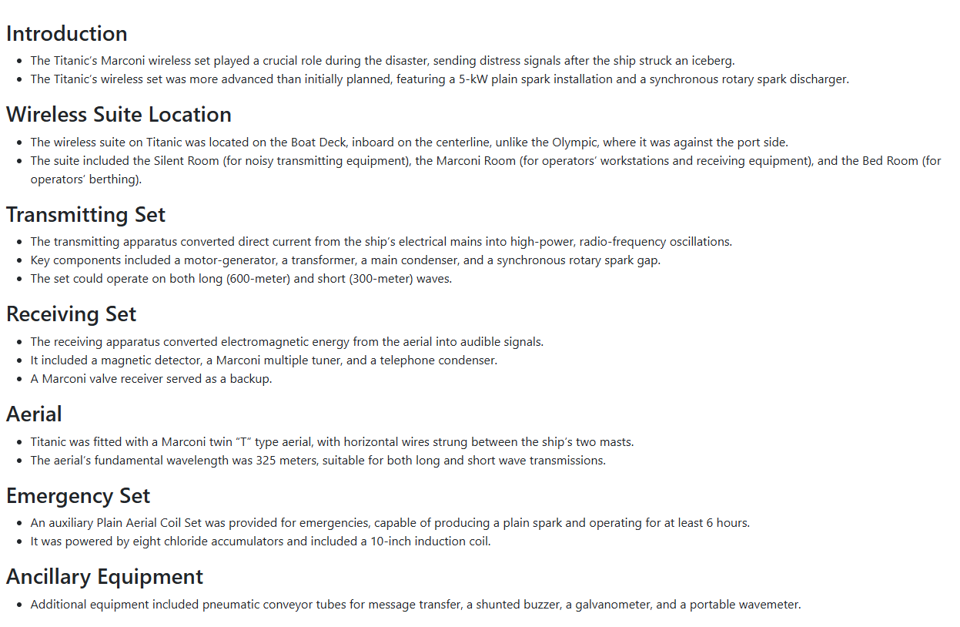
2

Camera Marconi (Marconi Room) de pe Titanic a fost centrul de comunicații wireless al navei, situată pe Puntea Bărcii. Operată de Jack Phillips și Harold Bride, aceasta a transmis mesaje cruciale și apeluri de ajutor (CQD/SOS) în noaptea scufundării (14-15 aprilie 1912), folosind un sistem puternic de 5 kW. Echipamentul a facilitat salvarea a peste 700 de vieți.Detalii cheie despre Camera Marconi:Structură: Era formată din trei încăperi distincte: o cameră principală de operare, o "cameră silențioasă" (Silent Room) pentru echipamentul zgomotos și o cameră de dormit (bunks) pentru operatori.Locație: Pe Puntea Bărcii, între punte și intrarea în Grand Staircase de la clasa I.Echipament: Dispunea de cel mai avansat sistem wireless Marconi de 5 kW, capabil să comunice pe distanțe mari.Operatorii: Jack Phillips (telegrafist șef) și Harold Bride (asistent), angajați ai Marconi Company.Ultimele momente: Phillips a continuat să transmită apeluri SOS chiar și pe măsură ce apa creștea, în timp ce Bride a ajutat la pasageri și a supraviețuit.Un aspect notabil al acestei camere a fost și confruntarea dintre operatori și un fochist care a încercat să fure o vestă de salvare în timpul scufundării. Astăzi, resturile camerei Marconi se află pe fundul oceanului.
Camera Marconi (Marconi Room) de pe Titanic a fost centrul vital de comunicații al navei, situat pe puntea bărcilor (Boat Deck) în cartierele ofițerilor. Aceasta a jucat un rol crucial în timpul scufundării, fiind locul de unde au fost trimise semnalele de ajutor care au dus la salvarea a peste 700 de persoane.
Detalii Cheie și OperatoriOperatori:
Camera a fost deservită de Jack Phillips (operator principal) și Harold Bride (junior), ambii angajați ai companiei Marconi.
Echipament: Dispunea de un sistem wireless Marconi de 5 kW, cel mai avansat de la acea vreme. Acesta includea un grup motor-generator și un disc descărcător pentru transmisiile în cod Morse
. Emițătoare cu Scântei Radio (Istoric)Acestea sunt primele tipuri de emițătoare radio folosite la începutul secolului XX.Istoric: Au fost folosite intens până în anii 1920.Principiu: Funcționau prin generarea unei descărcări electrice (scântei) între doi electrozi, ceea ce producea unde electromagnetice pe o bandă largă de frecvențe.Utilizare: Au fost esențiale pentru primele transmisii radio telegrafice, inclusiv în comunicațiile maritime timpurii.
Frecventa de lucru a statiei Marconi de 5KW este intre 300-600 de m, adica 1 MHz pina la 500 de KHz
Oscilator de banda larga, si un circuit acordat care se regla in frecventa de lucru

.Semnale de Distres:
După impactul cu aisbergul, Phillips a început să transmită codul de urgență CQD (specific Marconi)la conferinta din 1908 se hotarise trecerea la SOS, și ulterior SOS, care devenea noul standard internațional.
Eforturi Finale:
Cei doi operatori au continuat să trimită mesaje până când apa a inundat camera și nava a pierdut puterea electrică. Phillips a murit în urma dezastrului, în timp ce Bride a supraviețuit pe o barcă de salvare răsturnată.
Starea Actuală și Conservarea
În prezent, epava Camerei Marconi se află într-o stare avansată de degradare din cauza mediului marin.
Locație:
Epava se găsește la o adâncime de aproximativ 3.800 de metri în Oceanul Atlantic de Nord.Controverse legate de recuperare: Există dezbateri intense între istorici și companiile de explorare. Unii susțin că telegraful ar trebui recuperat pentru a fi expus într-un muzeu, în timp ce alții consideră că siteul trebuie lăsat neatins ca un memorial.
Vizibilitate:
Componente precum motorul-generator și părți ale telegrafului sunt încă vizibile în scanările subacvatice recente.

https://www.youtube.com/watch?v=FxRN2nP_9dA

https://www.sciencemuseum.org.uk/objects-and-stories/titanic-marconi-and-wireless-telegraph

https://titanic.fandom.com/wiki/Marconi_Room

https://www.hagley.org/librarynews/sarnoff/titanic-connection

The Marconi Room was the place where wireless operators Jack Phillips and Harold Bride held communication with ships and shore over a Marconi transmitter. Communication over the wireless worked using 'dots and dashes'. For example, 'S' is '...' and 'O' is '---'. When put together, you get the distress signal SOS sent during the sinking - '...___....' .When the purser brought messages from passengers to send forward, it was their job to send them to shore. Between those private messages, the operators also received messages from other ships, mostly iceberg warnings.

The room was part of the officers quarters and consisted of three small rooms, the first being the operators cabin or office, this room contained the equipment for the main marconi transmitter as well as an emergency transmitter, other equipment included pneumatic tubes and clocks made by the Magneta Time Co.

A small room to the left contained the operators berthing, as well as a wash basin and cupboard.

The "Silent room" was the name given to the room that was to the right of the operators cabin that contained the main transmitter, the ships T-type aerial also led into an insulator atop the roof of this room, it contained many pieces of electrical switch gear for controlling the wireless set, among these was a switch for switching over to the emergency set.

The room was destroyed during the sinking, not a lot is visible in pictures of the wreck except for switchgear hanging from their cables, the aerial most likely snapped during the sinking, and due to the high-voltages used, it is likely that pieces of switchgear exploded from being flooded out, sparks from the aerial lead-in were also seen by passengers during the sinking
Night of The Sinking
On the night of the sinking, 10:35 P.M., the Californian sent an iceberg warning to the Titanic. Jack Philips was on the telegraph when he got this message. Since the two ships were so close to each other, the message was screaming at Philips where he threw his headset off of him due to how loud it was. He then responded with this infamous message, "Shut up, shut up! I am busy, Cape Race!" The wireless on the Californian then shut off for the night after that message. The operators were both awake during the collision but ignored it. At 12:27 A.M., the first distress signal was sent. It read this, "CQD CQD CQD CQD CQD CQD MGY (Titanic) 40 44' N, 50 24' W" The first ship to respond to Titanic is the Frankfurt responding to them with, "What is the Matter?" At 12:29 A.M., Cape Race gets Titanic's distress signal and makes a CQ, which means "Attention to all stations" and says this, "This is Cape Race. MGY giving Pos. on CQD (lists Titanic's position). At 12:36 A.M., Officer Boxhall enters the wireless room to tell the operators the new given position but due to steam, Boxhall writes it on a piece of paper. Also at the same time, the Carpathia hears the distress signal. They don't ask them what is wrong but instead that Cape Cod is sending them a batch of messages to them. 2 minutes later, the wireless operator of the Carpathia is racing to the bridge to tell the captain that Titanic is sinking and needs help but the crew don't believe him. The operator eventually gets past them and demands the captain to get up. Soon after, the Carpathia is racing through the waters to Titanic. Nothing goes on throughout the night but a huge panic. The Olympic gets to chat with Titanic and starts to head for them but after Titanic is gone, Carpathia tells them that it will freak the passengers out to see another replica of Titanic rescuing them. As the night goes on, Philips get more desperate and desperate. At 2:10 A.M., the last message from Titanic is sent, "CQD MGY. THIS IS-" The message was interrupted due to a stoker walking into the Marconi room stealing their life jackets. Bride and Phillips fought back, resulting in the stoker being knocked unconscious. At that point they abandoned the Marconi room and ran out onto the boat deck. Harold Bride ran onto the roof of the Officer's Quarters to assist in preparing Collapsible Lifeboat B. Jack Philips ran to the stern. That was the last time he was seen. Harold Bride would survive the night while Jack Philips would not.

The Titanic Connection
Tuesday, August 23, 2016
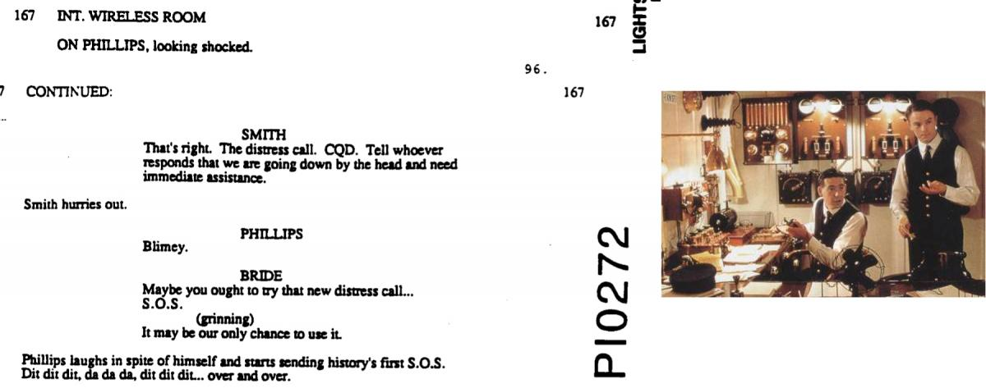
James Cameron's Titanic script and a still from the movie of the Marconi Room
Dah dah dah, dit dit dit, dah dah dah …
James Cameron’s blockbuster hit, Titanic, popularized the origins of the S.O.S. distress call, showing young wireless operators Jack Philips (25) and Harold Bride (21) tapping their pleas for assistance deep into the night. Finally, they reached the Carpathia, which arrived hours after the sinking to rescue 705 survivors. As Cameron was aware, the Titanic was equipped with a Marconi wireless telegraphy set, and both its operators were employed by the Marconi Company, and not White Star Line. Hagley now holds a small part of this story, in the form of over a thousand engineering drawings and design schematics from the Marconi Wireless Telegraphy Company of America, a part of the David Sarnoff Library collection.
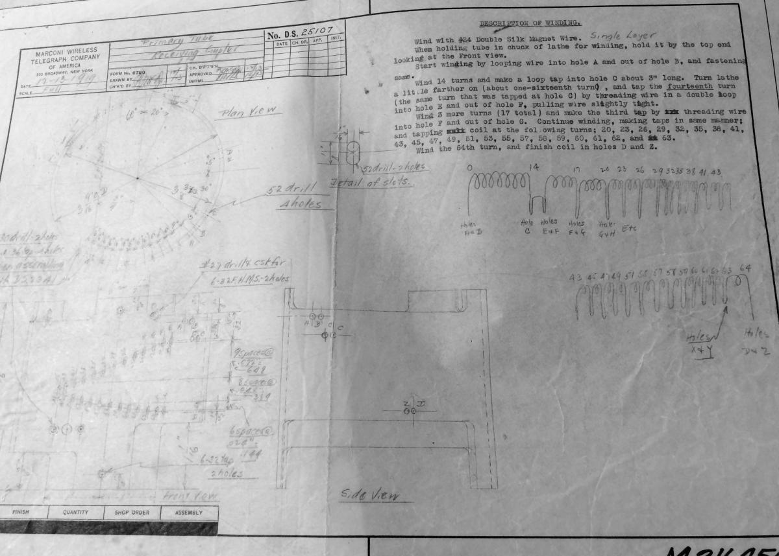
A design schematic describing a primary tube receiving coupler
Guglielmo Marconi [first name pronounced as: gool-YELL-moe] created his first transmitter-receiver in 1894 at 20 years old. In 1897, Marconi founded the Wireless Telegraph & Signal Company in London; expanding quickly overseas, the Marconi Wireless Telegraph Co. of America (MWTCA) was chartered in 1899. The company’s priority was creating wireless capabilities for ships and shore – it was this campaign which led to a Marconi radio on the Titanic in 1912.
The sinking of the Titanic was crucial for helping the public understand the importance of wireless technology, especially at sea. The British Postmaster General famously said, “Those who have been saved, have been saved by one man . . . Mr. Marconi and his marvelous invention.”
The United States responded with the Radio Act of 1912, making licenses mandatory for radio operators, and mandated ships continuously monitor for distress calls. While there aren’t any schematics of the actual equipment installed in the Titanic, the collection does reflect the rapidly expanding field of trans-Atlantic and marine wireless radio communications; most of the drawings are related to sea-radios in some way, and over a hundred drawings are specifically to fulfill contracts with the U.S. Navy, plus over fifty more for the U.S. Army Signal Corps.
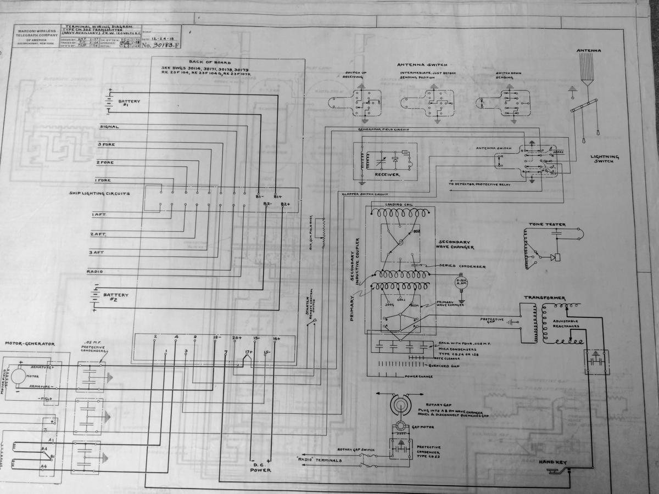
A Navy wireless transmitter terminal wiring diagram from 1918
Hagley holds 1300 engineering drawings from the Marconi Wireless Telegraph Company of America. Nearly three quarters of the drawings date 1917, 1918, and 1919 with the period 1905-1916 comprising the final quarter. From 1905-1916 represents the final quarter. Geographically, the majority seem to have been produced at MWTCA facilities in New York and New Jersey. However, they depict projects all over the world: Juneau, AK; New Orleans, LA; Havana, Cuba; San Antonio, TX; Argentina; Brazil; Honolulu, HI; and the U.S. Philippines, among others. The drawings range in subject from circuit diagrams, wiring layouts, and switchboard schematics to architectural plans for aerial towers and carrying case designs.
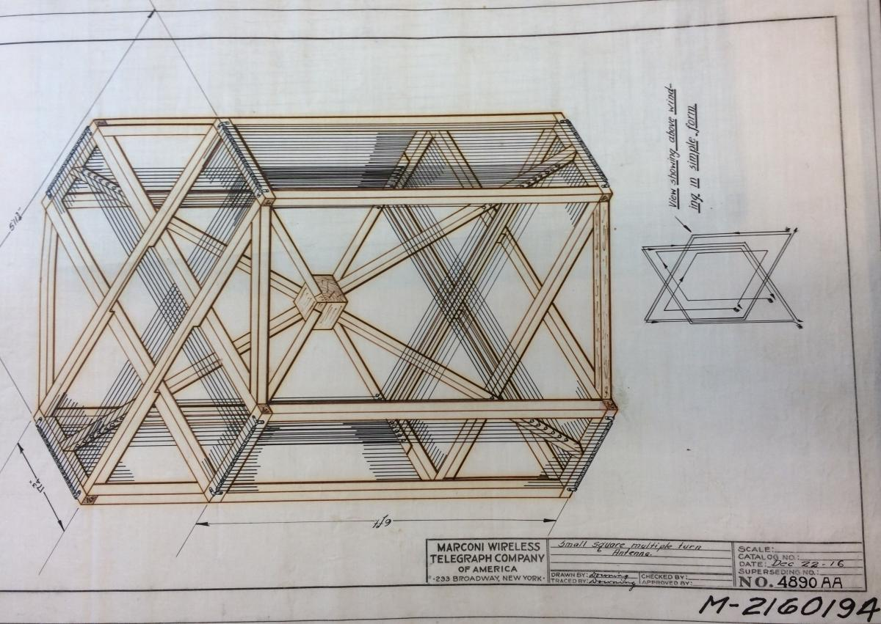
Sketch for a multiple-turn antenna that shows the skill involved in drawing many of these schematics
Edmund A. Laport, retired RCA engineer, looked over the collection in 1974 when it went up for sale. He recommended it be purchased for the Sarnoff Library, and reported back to RCA that:
One noticed clearly the extent to which equipment makers of that era had to make all their own components. There are all kinds of switches, variable condensers, goniometers, variometers, inductors, insulators, knobs, actuating mechanisms, fixed and rotary spark gaps, motor generators, battery-chargers, wavemeters, decremeters, and a host of other component details. That was before the time when all kinds of components could be bought from specialty manufacturers. [Letter from Edmund A. Laport to A. Pinsky, December 17, 1973.]
Oddities include an early airplane radio with a propeller power generator designed to attach to the wing of the plane, a mule-pack radio set for the Army Special Signal Corps complete with leather saddle schematics, a blimp radio installation guide, and equipment for both marine and flying boats. The collection also includes a surprising pioneer in global wireless communications that ordered equipment from MWTCA: the United Fruit Company, famous as propagator of ‘Banana Republics.’. Also in the collection is a 1913 design for mast caps at the station in South Wellfleet, Massachusetts, which had relayed the first message from the U.S. to England in 1903.
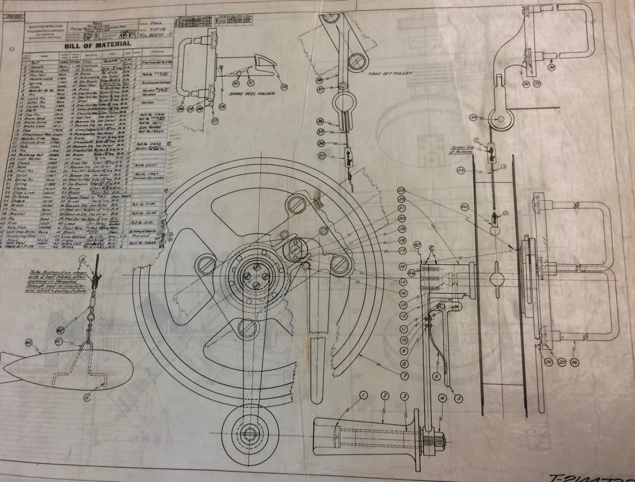
Sketch of parts for a ‘flying boat’ (AKA seaplane) transmitter
If naval communications spurred prosperity and success for MWTCA in the aftermath of the Titanic tragedy in 1912, the importance of oceanic transmissions also led to its demise in 1919. During World War I, the U.S. Navy seized control of almost all MWTCA assets for transmitting and receiving. In the aftermath, the United States realized they had no domestic wireless communications industry; the controlling stock in MWTCA was British. Seeking to safeguard America’s ability to communicate wirelessly with any nation, the Navy contacted General Electric, and arranged for the creation of an American-controlled company to buy out MWTCA.
This new company, The Radio Corporation of America, assumed control of all intellectual, material, and operating rights of the former MWTCA in 1919. In the transition, a young but ambitious former office boy by the name of David Sarnoff migrated from the MWTCA to RCA – but that’s a story for another blog post.
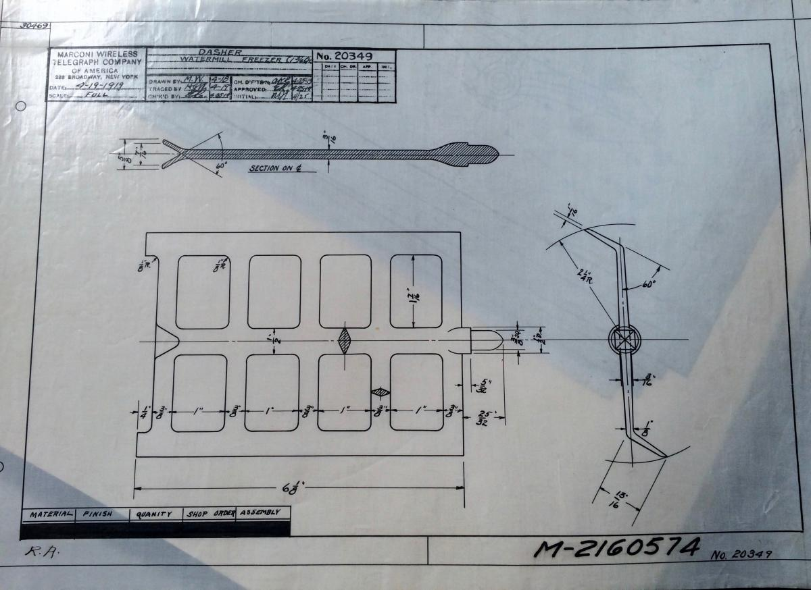
A final treat from the archives for a hot day – a ‘dasher’ meant for churning sweetened cream into ice cream, designed by the Marconi Wireless Telegraph Company of America! (The most surprising drawing in the collection, at least for this intern.)

Anastasia Day is the Summer 2016 Sarnoff Library Project Intern, working with the Manuscripts and Archives department in the Soda House. She is a doctoral student in history at the University of Delaware who studies the environment, technology, and society in the American twentieth century through food. Her dissertation is on Victory Gardens in World War II. Visit her website at www.thehistorianinthegarden.com.​

